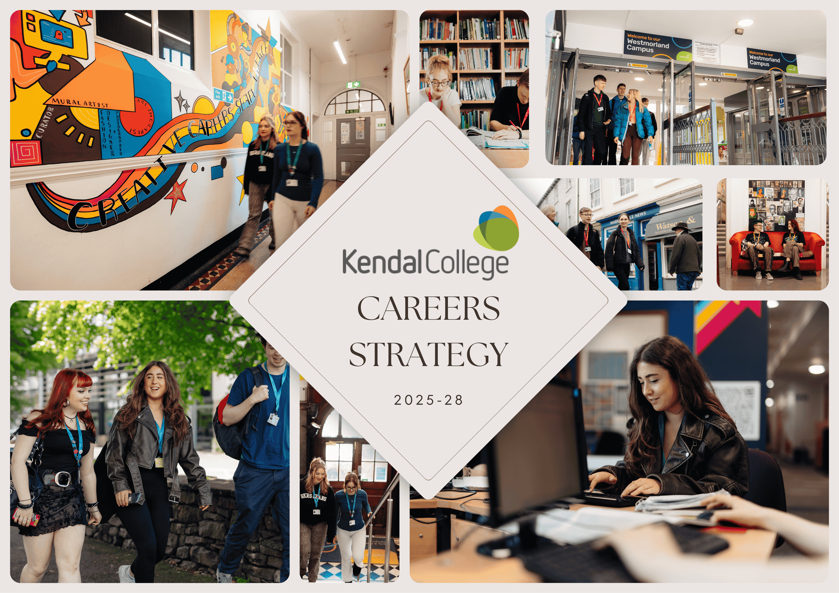
(Abridged version)
Introduction to Careers Education at Kendal College
This Careers Education, Information, Advice and Guidance (CEIAG) strategy and plan outline the new approach to delivering CEIAG taken by Kendal College. This strategy will be under pinned by an annual review and action plan. This new strategy for next three years has been developed by the support of the local Enterprise Advisor, Kendal College’s Director of Student Engagement, Support & Services; Careers team, Student Experience and Progression team and staff within Kendal college who would support & strategise to embed careers within respective curriculum areas.
The need for a fresh look at careers in curriculum is timely with several recent changes. The Government published its Careers Strategy in December 2017, but more recently followed by statutory guidance in May 2025 (Careers guidance and access for education and training providers - GOV.UK) , which outlines the expectations for careers provision in schools. The Department for Education (DfE) has published a new Strategic Action Plan in October 2025 (Department for Education 2024-25). The Government uses the 8 Gatsby Benchmarks as the national tool for ensuring national consistency of high-quality careers education, which was also recently updated in 2025.
Here are the eight current Gatsby benchmarks of Good Career Guidance:
- A stable careers programme
- Learning from Career and Labour Market Information
- Addressing the needs of each young person
- Linking curriculum learning to careers
- Encounters with employers and employees
- Experiences of workplaces
- Encounters with further and higher education
- Personal guidance
To support this realignment, an online self-evaluation tool, Compass, is available for colleges to assess how their careers support compares against the Gatsby Benchmarks and the national average. It has been updated in 2024. We are using these evaluative tools to identify areas for development in our careers provision.
The Government & Ofsted focus is to ensure that the Gatsby benchmarks are not only achieved, but are progressive, targeted, and impactful. The intention for careers is that it is the ‘golden thread’ that runs throughout Kendal College and therefore entertwine with our mission:
Unlocking Potential - Transforming Lives - Creating Bright Futures

We strive to provide all students at Kendal College, an entitlement to a Careers Education Information and Guidance Programme which enables, supports and empowers their career pathways. By actively promoting equity of opportunity and challenging stereotypes via our planned career activities and stakeholder collaboration, we believe we will contribute to greater awareness of career choices and raising aspirations. Therefore, Unlocking Potential.

We aim to incorporate Labour Market Information (LMI), local skills development and actively seek to work with employers and external stakeholders to ensure our staff are accurately informed in curriculum delivery along with creating positive and meaningful opportunities, developing employability skills for all students. Hence developing our whole community growth, Transforming Lives.

We endeavour to celebrate successes of our alumni and positive destination with a recognition of supporting aspirational career choices as a key element in promoting social mobility for all our students. We believe every student should be inspired to achieve a successful future and our CEIAG will support them in securing positive destinations. Thus, Creating Bright Futures.
Identifying Priority Benchmarks:

Benchmark | Academic year 22-23 | Academic year 23-24 | Academic year 24-25
Benchmark 1 | 100% | 100% | 94%
Benchmark 2 | 80% | 80% | 60%
Benchmark 3 | 75% | 100% | 91%
Benchmark 4 | 83% | 83% | 83%
Benchmark 5 | 100% | 100% | 100%
Benchmark 6 | 100% | 100% | 100%
Benchmark 7 | 91% | 100% | 100%
Benchmark 8 | 40% | 80% | 60%

Analysing our Compass scores for last 3 years reflected above, we have identified the following benchmarks as our goals for the next 3 years of our CEIAG delivery and provision:
Benchmark 2- Learning from Careers and Labour Market Information | Benchmark 3- Addressing the needs of each young person
Benchmark 4- Linking curriculum learning to careers | Benchmark 8- Personal Guidance

This give us clear objectives to fulfill via a combination of a SWOT analysis and RAG rating (Green-Achieved, Amber- In progress, and Red-Work needed) for evaluation, improvement and monitoring purposes. Below is a improvement summary for each Gatsby Benchmark.
For a complete detailed version, please refer to the full version of Careers Strategy, also available to be downloaded from the website at www.kendal.ac.uk
You can also contact Careers Leader Ash Mukherjee via Careers@kendal.ac.uk to ask for a detailed version or more details.
Gatsby Benchmarks and linked improvement plans in a summary:

Benchmark 1- A Stable Careers Programme:
Area of Focus (with RAG rating) | What This Means | Review Timeframe
Clear Careers Programme | Our careers plan is published on the college website. It’s easy for students, parents, and employers to access. | Updated annually (every July)
Student Feedback | We collect student views through surveys and forums to make sure the programme meets their needs. | Yearly
Parental Involvement | Parents/carers are invited to consultation events and given regular updates. | Termly
Employer Engagement | Local employers and training providers shape the programme and provide feedback. | Yearly
Inclusivity & NEET Support | Support is tailored for all learners, especially those at risk of being NEET. | Termly
Overall Programme & Policy Review | Full Careers Strategy, Policy and Programme reviewed to meet Ofsted and Gatsby requirements with Provider Access Legislation (PAL) and Career Leader’s details updated and visible. | Yearly (plus statutory 3-year cycle)
Review of Careers Offer | Via Compass evaluation | Termly

Benchmark 2- Learning from Career and Labour Market Information:
Area of Focus (with RAG rating) | What This Means | Review Timeframe
Labour Market Information (LMI) | Students and parents have access to up-to-date career and job market information through the website and events. | Yearly
Student Awareness | Students use LMI to help make decisions about courses, training, and future jobs. | Termly
Parental/ Carers Engagement | Parents / carers are signposted to LMI so they can support their child’s choices. | Termly
Employer & Provider Links | Employers, universities, and training providers contribute to sharing real job market insights via feedback, termly meetings and hub updates. | Termly
Staff Training | Staff are confident in using LMI and signposting students to reliable sources. | Yearly
Website Information | Careers and LMI resources are accessible online and regularly updated. | Yearly

Benchmark 3- Addressing the Needs of Each Pupil:
Area of Focus (with RAG rating) | What This Means | Review Timeframe
Personalised Support | Careers guidance tailored to individual needs; vocational profiling for EHCP, CLA, etc. | Termly
Record Keeping | Internal systems (Careers Tracker and Promonitor) track careers activities and guidance. | Termly
Staff Capacity | Need more trained advisors to meet demand across campuses. | Yearly
Alumni & Destinations | Destination data collected; alumni network used to inspire students. | Six monthly

Benchmark 4- Linking Curriculum Learning to Careers:
Area of Focus (with RAG rating) | What This Means | Review Timeframe
Curriculum Integration | Tutors link subject learning to careers; SMART targets set for work experience- ‘Careers and Futures’ space planned on MyKC. | Yearly
Career Champions | Staff and students to lead CEIAG in curriculum areas- developed via student reps and Curriculum Leads | Termly
Maths & English Relevance | Tutorials, Resources and videos to show real-world applications planned. | Yearly
Staff CPD | CPD on linking curriculum to careers needed- Delivered via staff development days, curriculum meetings and Career newsletters | Six monthly (Ongoing planning for 14th Feb 2025)

Benchmark 5- Encounters with Employers and Employees:
Area of Focus (with RAG rating) | What This Means | Review Timeframe
Employer Encounters | All students have at least two meaningful encounters annually. | Termly
Tracking & Evaluation | Compass and internal systems used to log and evaluate encounters. | Yearly
Feedback Collection | Learner feedback collected after each encounter. | Termly
Staff Capacity | SEPO/Careers team needs more staff to support matching and delivery. | Six monthly (New appointment of HF in Sept 2025, approved appointment of LOW for L6 guidance course)
Monthly Events & Enrichment Calendar | Aimed at employers, students and parents for better engagement- Fed via curriculum meetings through Career Lead | Termly

Benchmark 6- Experiences of Workplaces:
Area of Focus (with RAG rating) | What This Means | Review Timeframe
Work Experience | All vocational students complete work experience with timesheets and feedback. | Termly
Equity & Inclusion | Need better planning for learners with barriers (EHCP, CLA, etc.). | Termly
Curriculum Planning | Annual plans needed for meaningful experiences across all departments. | Yearly
Skill Portfolio for students | Plan to implement skill portfolio to link 8 essential skills (Skills Builder) & 6 industry specific skills to implement via SMART targets | Yearly

Benchmark 7- Encounters with Further and Higher Education:
Area of Focus (with RAG rating) | What This Means | Review Timeframe
HE/FE Encounters | Minimum two encounters per learner with HE/FE providers. (Termly curriculum meetings for targeted intervention) | Termly
Internal Events | Freshers Fayre, Careers Fair, and curriculum-led events planned annually and looked at feedback and impact to gauge effectiveness. | Yearly
Provider Engagement | Meetings with external education providers to build opportunities. | Termly
Funding & Access | Arranged for funding for trips and events (Hello Future, University collaborations and Northwest Farmers Trust etc.); more collaboration needed for new grants. | Yearly

Benchmark 8- Personal Guidance:
Area of Focus (with RAG rating) | What This Means | Review Timeframe
1:1 Guidance | All learners receive personal guidance up to age 18 years. (25 years with EHCP) spread and visible at all 3 campuses | Termly
Staff Qualifications | Careers team includes Level 6 and Level 4 advisors; more staff training needed. | Yearly
NEET or risk of NEET Support | Targeted guidance for learners with barriers; collaboration with Inspira and LCC. (Building relations in Yorkshire County) | Yearly
Parental Engagement | Careers guidance shared with parents via events (virtual 1-1 & Campus drop-in events) and surveys. | Yearly

Summarising Key Strategic Points from the Plan (Working in 2025-2028):

- Streamlining our efforts from policy, strategy and programme for careers on various channels (website, events, drop-ins, newsletters, feedback etc) with a whole college approach; providing information to all stakeholders including external providers and employers along with a special focus on learners and parents/carers/guardians.
- Aiming to provide 1-1 personal guidance to all learners and robust system for all learners with any barriers (with EHC Plan, Young Carers, CLAs, etc.)
- Staff CPD has focus on delivering careers and LMI dissemination.
- Raise awareness of Maths and English in careers via various methods. (Career Champions, newsletters, videos, tutorials, events etc.)
- Future Skills and Destination Questionnaire must be mandatory to gauge impact and plan effectively.
- Parents/Carers/Guardians engagement to be increased and embedded from start of academic year.
- Clearer marketing strategy for careers on website and other channels.
- Visibility for careers in each campus with dedicated space for careers guidance as well as virtual access to ‘destinations’ resources on MyKC.
- Access participation plan (a fund created) to bridge gaps for students with any barriers to education or training needs to be planned. For example, DBS cost support, Placement T-shirt cost etc.
- Dedicated careers budget for various activities planned and funded through the year.

