

BUSINESS CONTINUITY &

DISASTER/INCIDENT RECOVERY PLAN
for

Kendal College

UPDATED FEBRUARY 2026 - Pending Board Approval April 2026

College Sites & Addresses | Milnthorpe Road  Kendal College Milnthorpe Road  Kendal  Cumbria  LA9 5AY | Creative Arts Centre  Beezon Road  Kendal  Cumbria  LA9 6EL | Kendal Museum Station Road  Kendal  Cumbria  LA9 6BT | Wildman Street Studios  30 Wildman Street  Kendal  Cumbria  LA9 6EN | Westmorland Campus  Stricklandgate  Kendal  Cumbria  LA9 4LR
Telephone Numbers | 01539 814700 | 01539 814634 | 01539 815587 | 01539 814634 | 01539 814614

Contact Names | Jason Turton – Principal
Disaster Recovery Manager | Jason Turton – Principal
Deputy/Assistant Disaster Recovery Manager (s) | Sinead Kay, Chief Operating Officer  Richard Evans, Deputy Principal, Education and Standards

Note: Separate Disaster Recovery Plan is in place for Kendal Museum

CONTENTS

Page Number

1. Introduction 3

2. Aims & Purpose 3

3. Role of Disaster/Incident Team 3

4. Disaster Recovery Team 4 - 5

5. Assessing and Managing the Incident 6 - 9

6. Other Relevant Procedures and Guidance 9

7. Disaster/Incident Log 9

8. Monitoring and Managing the Plan 9

Appendices

Appendix 1 Key Suppliers Names and Telephone Numbers 10 - 11

Appendix 2 Site and Floor Plans 12 - 24

Appendix 3 Media and Local Services Telephone Numbers 25

Appendix 4 Disaster/Incident Event Log 27

Appendix 5 Total Network Documentation

Distribution List

This document and all amendments are distributed as follows:

Kendal College

Electronic Distribution

Principal
Deputy Principal – Education and Standards
Chief Operating Officer
Directors of Curriculum
Heads of Faculty
Head of Estates
Health and Safety Manager
Network Manager
HR Manager
Director of Student Services
Marketing Manager
Principal’s Office
Helpdesk

Hard Copy

Reception Desk (Milnthorpe Road)
Reception Desk (Westmorland Campus)
Reception Desk (Arts and media campus)

In addition, this Plan will be available on the College Staff Portal, College website, and on standalone laptops in strategic locations on all campuses.

1. Introduction

A disaster or major incident is defined as any significant event — sudden or developing — that threatens the safety of people, the integrity of buildings or infrastructure, the security of data and systems, the College’s financial stability, or its ability to deliver education and training.
Such incidents may require the activation of special measures to protect life, safeguard learners and staff, maintain critical operations, and restore sustainable delivery within agreed recovery timeframes.
Incidents may include (but are not limited to):
- Fire, flood, structural failure or other physical damage
- Severe weather or environmental events
- Pandemic or public health emergencies
- Cyber-attack, ransomware or data breach
- Loss of utilities or digital infrastructure
- Safeguarding crisis or serious incident
- Major health and safety incident
- Significant financial disruption
- Regulatory intervention or reputational crisis
As a multi-site further education college operating within a complex regulatory and funding environment, Kendal College recognises that business continuity extends beyond physical estate recovery. It includes maintaining educational delivery, protecting vulnerable learners, safeguarding critical data, sustaining financial resilience, and preserving public confidence.
This Business Continuity and Disaster/Incident Recovery Plan sets out the framework through which the College will:
- Protect people first
- Stabilise operations
- Maintain critical teaching and support functions
- Safeguard financial and digital infrastructure
- Recover in a structured and accountable manner
- Learn and strengthen organisational resilience following any incident
The Plan forms part of the College’s wider strategic risk management framework and is subject to regular review, testing and governance oversight.

2. Aims & Purpose

This Business Continuity and Disaster/Incident Recovery Plan is designed to provide a structured, proportionate and risk-informed framework to protect the College, its people and its educational mission in the event of a major incident.
The aims of this Plan are to:
- Protect life and wellbeing first, ensuring the safety of students, staff, visitors and partners at all times.
- Minimise disruption to teaching, learning and support services, particularly for vulnerable learners and those undertaking time-sensitive programmes or assessments.
- Stabilise critical operations quickly, including safeguarding, IT systems, estates, finance and student support functions.
- Safeguard the College’s physical, digital and financial assets, including data protection and regulatory compliance.
- Provide a clear and accountable decision-making structure, with defined roles, responsibilities and escalation routes.
- Maintain transparent and timely communication with staff, students, parents, employers, regulators, governors and other stakeholders.
- Enable structured recovery within agreed recovery time objectives, restoring sustainable operations as soon as reasonably practicable.
- Maintain regulatory and funding compliance, including engagement with ESFA, awarding bodies, Ofsted and other relevant agencies where required.
- Capture and document actions taken, ensuring accurate incident logging, review and audit trail.
- Review and strengthen organisational resilience following any incident, embedding learning and continuous improvement.
This Plan supports the College’s wider strategic objectives relating to organisational health, financial resilience, safeguarding, and high-quality educational delivery. It is reviewed regularly and tested periodically to ensure preparedness, responsiveness and governance assurance.

3. Role of Disaster/Incident Team

In the event of a suspected or confirmed major incident, the Principal (Disaster Recovery Manager) must be informed immediately. Where the Principal is unavailable, authority transfers to the designated Deputy Disaster Recovery Manager.

3.1 Immediate Assessment
The Disaster Recovery Manager will initiate an initial situation assessment to establish:
- Nature and classification of the incident
- Immediate risk to life, safeguarding or wellbeing
- Extent of physical, digital or operational impact
- Impact on teaching, learning and student support
- Status of IT systems and data integrity (where applicable)
- Financial and regulatory implications
- Access to affected premises or systems
- Estimated duration of disruption
Incidents will be proportionately classified (for example):
- Tier 1 – Localised Incident: Limited operational impact, managed at departmental level
- Tier 2 – Significant Incident: Multi-area disruption requiring formal Disaster Recovery Team activation
- Tier 3 – Critical Incident: Major threat to safety, continuity or reputation requiring full activation, Governor notification and potential regulatory engagement

3.2 Activation of the Disaster Recovery Team
Where a Tier 2 or Tier 3 incident is identified, the Disaster Recovery Manager will:
- Convene the Disaster Recovery Team immediately
- Confirm the physical or virtual meeting location
- Establish secure communication channels
- Issue immediate protective instructions where required
- Confirm decision-making authority and delegation
The Team will operate under a clear command structure and maintain a formal incident log from the point of activation.

3.3 Phase 1: Stabilisation (0–48 Hours)
The initial priority is:
- Protection of life and safeguarding
- Securing affected premises or systems
- Containment of further risk or damage
- Maintaining critical services (safeguarding, communications, payroll, IT core systems)
- Notifying emergency services, regulators or insurers where required
The Disaster Recovery Team will meet regularly (physically or virtually) and record decisions, actions and responsible leads.

3.4 Phase 2: Continuity (2–7 Days)
Once immediate risk is stabilised, the Team will:
- Implement temporary delivery models where required
- Activate alternative teaching or working arrangements
- Assess financial exposure and resource impact
- Confirm stakeholder communication strategy
- Notify the Chair of Governors (for Tier 3 incidents)
- Engage regulators or funding bodies if required
Meeting frequency will be formalised and documented.

3.5 Phase 3: Recovery & Restoration
Beyond the initial stabilisation period, the Team will:
- Agree a structured recovery plan
- Establish recovery time objectives
- Identify mid-to-long-term infrastructure or operational requirements
- Review financial implications and insurance processes
- Prepare formal reporting to Governors

3.6 Governance and Escalation
For Tier 3 incidents:
- The Chair of Governors must be informed at the earliest opportunity
- The Audit & Risk Committee will receive a formal post-incident report
- Where required, the Board will review recovery plans and financial implications

3.7 Post-Incident Review
Following resolution, the Disaster Recovery Team will:
- Conduct a structured lessons-learned review
- Assess organisational resilience
- Update risk registers where necessary
- Recommend improvements to systems, training or policy
.

4. Disaster Recovery Team

Function | Name | Contact Numbers
Disaster Recovery Manager | Jason Turton  Principal | M: 07776 374915
Deputy Disaster Manager (s) | Craig Owen,  Vice Principal, Finance Data and Funding  Richard Evans  Deputy Principal Education and Standards  Sinéad Kay  Chief Operating Officer | M: 07487 575346  M: 07778 513830  M: 07837 581121
Local Authority & Education and Skills Funding Agency Liaison | Jason Turton | M: 07776 374915
Media Liaison | Hilary Pezet | H: 07900354645
Staff Liaison | Richard Evans  Deputy Principal Education and Standards | M: 07778 513830
Student Liaison | Hilary Pezet  Gayle Salt  Director of Curriculum | M: 07900354645  M: 07580 085801
Employer Liaison/  apprenticeship | Lydia Read-Potter | M: 07721111757
IT Recovery Systems | Craig Owen  Vice Principal, Finance Data and Funding  Sinéad Kay  Chief Operating Officer  Sam Rowles  IT Network and Digital Learning Manager | M: 07487 575346  M: 07837 581121  M: 07415252317
Insurance Claim/ Recovery Financing | Elaine Gilpin  Head of Finance  Kevin Lightley  Site Supervisor  Karl Birch (WMC/AMC  Site Supervisor | M; 07985 279726  M: 07525 812633  M: 07515062617

Function | Name | Contact Numbers
Premises and Equipment Resources  Site Security | Tim Ashberry  Head of Estates  Kevin Lightley  Site Supervisor (Milnthorpe)  Gary Howard  Karl Birch (Westmorland and Arts)  Site Supervisor  Phil Dudley  Health and Safety Manager | M: 07967 583079  M: 07525 812633  M: 07525 234439  M: 07515 062617  M: 07590 445474
Curriculum Issues (course material, examinations, etc.) | Kelli Horner  Gayle Salt  Director of Curriculum  Richard Evans  Deputy Principal Education and Standards | H: 01539 814617  M: 07580 085801  H: 01229 889664  M: 07778 513830

5. Assessing and Managing the Incident

Assessing and Managing the Incident – Buildings & Estate (Disaster Recovery Management Centre) | In the event of a major incident affecting College premises, a designated Disaster Recovery Management Centre will be established to coordinate operational response and recovery.  The primary coordination location will be:  - Principalship Office, Milnthorpe Road (Main Site)  If this location is inaccessible, alternative coordination centres will be activated in the following order:  - Allen Building Reception  - Westmorland Campus  - A secure virtual command structure using remote digital access  The Disaster Recovery Management Centre may incorporate support from:  - College Reception / Switchboard  - Finance and Administration  - HR / Personnel  - Student Records  - IT Services  Where physical access is restricted, remote working protocols will be activated to ensure continuity of leadership, safeguarding, payroll and communications.  Multi-Site Risk Consideration  Kendal College operates across multiple campuses. While the geographical separation of sites reduces the likelihood of simultaneous physical impact, business continuity planning assumes that:  - Infrastructure interdependencies (IT systems, utilities, staffing) may create cross-site disruption  - Severe weather or cyber incidents may affect all campuses simultaneously  - Transport or public health emergencies may disrupt multiple locations at once  Planning assumptions therefore avoid reliance on geographic separation as a primary mitigation.  Immediate Estate Response Actions  Where buildings are affected, the Disaster Recovery Team will prioritise:  - Safety and Site Security  - Secure premises in conjunction with emergency services and specialist contractors  - Ensure safeguarding of vulnerable learners  - Prevent unauthorised access  - Damage and Operational Assessment  - Assess structural, utility and environmental safety  - Determine short-, medium- and long-term loss scenarios  - Identify critical facilities (safeguarding spaces, IT rooms, examination areas)  - Alternative Accommodation Strategy  - Identify temporary accommodation options including:  - Local schools or partner providers  - Modular buildings (portacabins)  - Local authority or council land  - Community venues (e.g. Parish Hall, Brewery Arts Centre)  - Ensure accessibility, safeguarding and health & safety compliance  - Maintain exam and assessment integrity  - Optimisation of Remaining Estate  - Reconfigure timetables  - Prioritise vulnerable or examination cohorts  - Implement blended or remote delivery where appropriate  - Planning and Insurance Liaison  - Engage with planners, insurers and contractors  - Oversee temporary build installation  - Manage long-term capital recovery in coordination with Finance  - Digital Infrastructure Protection  - Ensure IT server rooms, network hubs and data storage areas are protected  - Confirm integrity of backups and remote access capability  Recovery Governance  All estate-related recovery actions will:  - Be logged formally  - Be cost-tracked for insurance and audit purposes  - Be reviewed by the Finance Lead  - Be reported to Governors where impact exceeds agreed financial thresholds | T Ashberry  J Turton  K Lightley  T Ashberry  K Lightley  J Turton  T Ashberry  K Lightley  J Turton
Equipment & Digital Infrastructure Recovery | The rapid restoration of essential equipment, IT systems and teaching resources is critical to maintaining educational delivery and organisational stability.  Recovery planning will prioritise continuity of safeguarding, payroll, communications, teaching delivery and regulatory compliance.  1. Initial Damage and Impact Assessment  Immediately following stabilisation of the site or systems, the Disaster Recovery Team will:  - Assess the extent of physical damage to equipment and infrastructure  - Confirm the operational status of:  - IT servers and network infrastructure  - Cloud-based systems  - Telephony and communications platforms  - Specialist teaching equipment (e.g. engineering, hospitality, digital labs)  - Identify any compromised data, software or cybersecurity risks  - Confirm integrity of backups and restoration capability  Where a cyber-incident is suspected, the IT Lead will implement network isolation protocols and follow the College’s Cyber Incident Response Annex.  2. Equipment Prioritisation Framework  Replacement and reinstatement will follow a prioritised model:  Priority 1 – Critical Infrastructure  - Safeguarding systems  - Student records  - Payroll and finance systems  - Core IT network and connectivity  - Examination and awarding body systems  Priority 2 – Teaching & Learning Continuity  - Devices required for delivery (laptops, PCs, AV systems)  - Curriculum-critical specialist equipment  - SEND and accessibility equipment  Priority 3 – Full Operational Restoration  - Non-critical administrative equipment  - Enhancement resources  - Long-term capital upgrades  This prioritisation ensures continuity of core educational and statutory functions before full reinstatement.  3. Procurement and Financial Control  The Disaster Recovery Manager, in conjunction with the Finance Lead, may:  - Activate emergency procurement procedures  - Approve temporary suspension of standard procurement thresholds where required  - Ensure cost tracking for insurance recovery  - Maintain an auditable record of all replacement purchases  All expenditure will be logged and reviewed in line with financial regulations and reported to Governors where appropriate.  4. Insurance and Supplier Coordination  The Team Member responsible for insurance and recovery financing will:  - Liaise with insurers and loss adjusters  - Ensure accurate documentation of damage  - Coordinate with approved suppliers and contractors  - Confirm compliance with policy conditions  Key suppliers and utility contacts are listed in Appendix 1.  Site and floor plans are included in Appendix 2.  5. Digital Continuity & Data Recovery  In the event of system failure or cyber disruption:  - Cloud backups and off-site storage will be verified  - Recovery Time Objectives (RTO) and Recovery Point Objectives (RPO) will guide restoration sequencing  - External cybersecurity advisors will be engaged if required  - ICO and ESFA reporting thresholds will be assessed where data breach is suspected  Where full system restoration is delayed, interim digital workarounds (secure remote platforms, temporary networks) will be implemented.  6. Supply Chain Disruption Planning  Where national or regional supply disruption affects replacement timelines:  - Temporary leasing or shared resource models may be used  - Curriculum sequencing may be adjusted  - Remote or blended learning models may be deployed  Details of key suppliers and utility companies is included in Appendix 1  A copy of the site and floor plans is included in Appendix 2 | S Rowles  S Rowles  S Kay  S Rowles  S Kay  E Gilpin  S Kay  T Ashberry  S Kay  E Gilpin  S Rowles  T Ashberry  S Kay
Media and Communications Management | In the event of a significant incident, proactive, accurate and controlled communication is essential to protect individuals, maintain public confidence and safeguard the College’s reputation.  All external communications relating to the incident will be centrally coordinated through the designated Media Liaison Lead.  1. Media Control Protocol  Immediately following activation of the Disaster Recovery Team:  - All staff will be formally instructed that no individual is authorised to speak to the media, post on social media, or provide informal commentary.  - All media enquiries (press, broadcast, digital, freelance journalists) must be redirected to the Media Liaison Lead.  - A holding statement will be prepared and approved by the Disaster Recovery Manager before release.  Failure to follow communication protocols may compromise safeguarding, legal compliance or insurance conditions.  2. Communications Governance  All public statements will:  - Be approved by the Disaster Recovery Manager  - Align with safeguarding, legal and data protection obligations  - Be consistent with regulatory reporting (ESFA, Ofsted, HSE, ICO where applicable)  - Avoid speculation or attribution of blame  - Protect confidentiality of students, staff and families  Where a fatality or serious injury has occurred:  - Communication will be coordinated sensitively with emergency services and family representatives  - No names will be released without confirmed consent  - Appropriate condolences and acknowledgement will be issued  3. Social Media and Misinformation Management  Given the speed at which information spreads online:  - The Marketing/Communications Lead will monitor social media platforms  - Inaccurate or harmful misinformation will be corrected where appropriate  - Official updates will be issued via:  - College website  - Official social media channels  - Email communication to stakeholders  - Staff will be reminded of professional conduct expectations under the Staff Code of Conduct  4. Stakeholder Communications  In addition to press engagement, the following groups may require targeted communication:  - Students  - Parents/carers  - Apprentices and employers  - Governors  - Regulators and funding bodies  - Local authority partners  - Insurers  Communications will be proportionate, factual and timely.  5. Cyber Incident Communications  In the event of a cyber-attack or data breach:  - Public messaging will avoid technical detail that may compromise security  - ICO reporting obligations will be assessed  - Affected individuals will be informed in accordance with data protection law  - Law enforcement guidance will be followed where applicable  6. Communication Phases  Media communication will follow a structured approach:  Phase 1 – Holding Statement  Brief confirmation that the College is aware of the incident and taking appropriate action.  Phase 2 – Stabilisation Update  Confirmation of safety measures and operational adjustments.  Phase 3 – Recovery Update  Information on restoration of services and support available.  7. Record Keeping  All public statements, media interactions and stakeholder communications will be logged as part of the formal incident record.  Key media contact details are provided in Appendix 3. | J Turton  R Evans  J Turton  H Pezet  J Turton  H Pezet  H Pezet  H Pezet  G Salt  L Read-Potter  J Turton  H Pezet  S Rowles  S Kay  J Turton  H Pezet  J Turton  H Pezet
Communication with Regulators and External Stakeholders | In the event of a significant incident, timely and proportionate communication with regulators, funding bodies and partners is essential to ensure compliance, maintain confidence and protect the College’s legal, financial and reputational position.  The Disaster Recovery Manager will determine notification requirements based on incident severity and statutory obligations.  1. Regulatory and Statutory Notifications  Where applicable, the following bodies may require formal notification:  - Department for Education (DfE) – where funding, financial stability, safeguarding or major operational disruption is impacted  - Ofsted – where educational delivery, safeguarding or learner welfare is significantly affected  - Health & Safety Executive (HSE) – in line with RIDDOR reporting requirements  - Information Commissioner’s Office (ICO) – in the event of a reportable data breach  - Awarding Bodies and Examination Boards – where assessment integrity may be affected  - Local Authority Safeguarding Partnerships – in safeguarding-related incidents  - Police or Emergency Services – where criminal or serious safety matters arise  Notification thresholds will be assessed promptly and documented in the incident log.  2. Governors  For Tier 3 or critical incidents:  - The Chair of Governors will be informed at the earliest opportunity.  - A briefing note will be prepared for the Corporation.  - The Audit & Risk Committee will receive a formal post-incident report.  - Where financial exposure exceeds agreed thresholds, immediate board oversight will be activated.  3. Employers and Apprenticeship Partners  Where apprenticeships or employer-based training are affected:  - Employers will be informed of operational adjustments.  - Alternative delivery or assessment arrangements will be confirmed.  - Compliance with apprenticeship funding rules (now overseen by DfE) will be reviewed.  4. Insurers and Funding Partners  The College’s insurers must be notified promptly in the event of:  - Property damage  - Business interruption  - Liability claims  - Cyber incidents  All communications with insurers will be documented to protect policy conditions.  5. Trade Unions and Staff Representatives  Where an incident materially affects working conditions or staffing arrangements:  - Recognised trade unions will be informed appropriately.  - HR will ensure compliance with employment law obligations.  6. Documentation and Record Keeping  All regulatory and stakeholder communications will:  - Be formally logged  - Be approved by the Disaster Recovery Manager  - Be aligned with media and safeguarding communications  - Be retained for audit and governance review | J Turton  J Turton  R Evans  S Kay  T Ashberry  B Lowery  G Salt  T Breeze  L Read-Potter  T Ashberry  E Gilpin  S Kay  M Croukamp  J Turton
Staff Liaison | In the event of a significant incident, clear, structured and supportive communication with staff is essential to maintain safeguarding, operational stability and organisational confidence.  The Disaster Recovery Team will ensure that workforce wellbeing, continuity and compliance are central to the response.  1. Immediate Staff Communication  As soon as practicable following incident confirmation:  - A verified update will be issued to all staff via official channels (email, intranet, SMS where appropriate).  - Line managers will receive briefing guidance to ensure consistent messaging.  - Staff will be informed of:  - Safety arrangements  - Site access restrictions  - Interim working arrangements  - Expectations regarding communication conduct  All communication will be approved by the Disaster Recovery Manager and aligned with external messaging.  2. Workforce Continuity and Deployment  Where operational disruption occurs, the College may:  - Activate remote working arrangements  - Temporarily reallocate staff to critical functions  - Prioritise safeguarding, student support and payroll functions  - Adjust timetables or duties as required  Business-critical roles will be identified and supported to maintain continuity.  3. Safeguarding and Professional Conduct  Staff will be reminded that:  - Safeguarding responsibilities remain in force during disruption  - No unauthorised communication with media is permitted  - Confidential information must not be shared externally  - Social media commentary relating to the incident must comply with the Staff Code of Conduct  4. Agency and Contracted Staff  Where the College utilises agency or contracted personnel:  - Agencies will be informed of operational changes  - Continuity of provision will be reviewed  - Contractual implications will be assessed  5. Staff Wellbeing and Psychological Support  Incidents may have a significant emotional or psychological impact. The College will:  - Provide access to counselling and wellbeing support (via NHS or Employee Assistance Programme where available)  - Offer targeted support for teams directly affected  - Ensure managers are briefed on trauma-informed responses  - Facilitate reasonable adjustments where appropriate  6. Trade Union and Representative Engagement  Where incidents materially affect working conditions:  - Recognised trade unions will be informed appropriately  - HR will ensure compliance with employment law obligations  - Consultation requirements will be observed where required  7. Governors  For Tier 3 or critical incidents:  - Governors will receive a strategic briefing from the Principal.  - Communications will distinguish between operational detail and governance oversight.  8. Managing Incoming Enquiries  A structured system will be in place to:  - Respond to staff queries  - Escalate safeguarding or welfare concerns  - Log significant issues raised  - Maintain consistent and transparent communication | J Turton  M Croukamp  J Turton  M Croukamp  J Turton  M Croukamp  J Turton  M Croukamp  J Turton  M Croukamp  J Turton  M Croukamp  J Turton  T Breeze  J Turton  M Croukamp
Student Liaison | Clear, timely and safeguarding-led communication with students is critical to maintaining wellbeing, continuity of learning and public confidence during a major incident.  The Disaster Recovery Team will ensure that student welfare and educational continuity remain central to all decisions.  1. Immediate Communication  As soon as practicable following incident confirmation:  - A verified update will be issued via official College channels (website, email, SMS where available).  - Students will be informed of:  - Safety arrangements  - Site closures or restrictions  - Interim teaching arrangements  - Expected next steps  - Parents/carers will be informed where appropriate, particularly for 16–18 learners.  All messaging will align with media communications and safeguarding requirements.  2. Safeguarding and Vulnerable Learners  Priority will be given to:  - Learners with Education, Health and Care Plans (EHCPs)  - Students receiving safeguarding support  - Students known to be at risk  - Learners requiring SEND adjustments  Where necessary:  - Direct contact will be made with vulnerable learners and/or families  - Alternative safe spaces or arrangements will be confirmed  - Designated Safeguarding Leads will remain accessible  Safeguarding reporting routes will remain operational throughout the incident.  3. Continuity of Learning  Where physical attendance is disrupted:  - Blended or remote delivery models will be activated  - Teaching materials will be made available via digital platforms  - Curriculum sequencing may be adjusted to prioritise examination cohorts  - Reasonable adjustments will be made for SEND learners  Awarding bodies will be engaged where assessment integrity may be impacted.  4. Apprentices and Employers  Where apprenticeship provision is affected:  - Apprentices will receive direct communication outlining next steps  - Employers will be informed of any delivery or assessment adjustments  - Compliance with DfE funding rules will be maintained  - Off-the-job learning records will be safeguarded  Alternative workplace or remote delivery models will be deployed where required.  5. Student Wellbeing and Support  Where incidents are distressing or traumatic:  - Counselling and wellbeing support will be offered  - Student Services will coordinate targeted support  - Staff will be briefed on appropriate pastoral responses  - Group or individual support sessions may be arranged  In cases of serious incident or fatality, communication will be trauma-informed and aligned with external agency guidance.  6. Managing Incoming Enquiries  A structured response system will be established to:  - Handle calls, emails and digital enquiries  - Provide consistent information  - Escalate safeguarding concerns appropriately  - Protect confidential information  All enquiries will be logged where appropriate.  7. Data Protection and Confidentiality  All student communications will:  - Protect personal data  - Avoid disclosure of sensitive information  - Comply with data protection legislation | R Evans  G Salt  S Kay  H Pezet  S Rowles  S Rowles  R Evans  R Evans  B Lowery  G Salt  R Evans  B Lowery  G Salt  R Evans  B Lowery  L Read-Potter  R Evans  B Lowery  G Salt  J Turton  H Pezet  J Turton  H Pezet  T Breeze
IT Systems and Data Recovery | The protection and recovery of digital systems and data are critical to safeguarding learners, maintaining payroll and financial integrity, preserving regulatory compliance and ensuring continuity of teaching and learning.  The College operates a daily off-site backup system and system replication architecture. However, business continuity planning assumes potential disruption, data compromise or system failure and therefore does not rely solely on replication as mitigation.  A detailed IT Recovery Plan is included in Appendix 4 and operates in conjunction with this Business Continuity Plan.  1. Immediate System Assessment  Upon activation of the Disaster Recovery Team, the IT Lead will:  - Assess the operational status of:  - Core network infrastructure  - Servers and storage  - Cloud-hosted systems  - Student records systems  - Finance and payroll systems  - HR systems  - Safeguarding databases  - Confirm integrity of backups  - Determine whether a cyber incident is suspected  - Isolate affected systems where necessary  Where a cyber-attack or ransomware event is suspected, the Cyber Incident Response Protocol will be activated immediately.  2. Data Protection and Regulatory Considerations  Where data integrity is compromised:  - The risk of personal data breach will be assessed  - Reporting thresholds under UK GDPR will be considered  - The Information Commissioner’s Office (ICO) will be notified where required  - Affected individuals will be informed in accordance with legal obligations  No assumption will be made that replication eliminates risk of data loss.  3. Recovery Prioritisation Framework  System restoration will follow a structured priority model:  Priority 1 – Safeguarding and Statutory Systems  - Safeguarding reporting systems  - Student attendance and welfare records  - Payroll  - Finance systems  - Communication platforms  Priority 2 – Teaching and Learning Systems  - Virtual Learning Environments  - Timetabling  - Assessment tracking  - Examination systems  Priority 3 – Full Operational Systems  - Non-essential administrative platforms  - Enhancement or development systems  Recovery Time Objectives (RTO) and Recovery Point Objectives (RPO) will guide sequencing and documentation.  4. Hardware and Infrastructure Restoration  Where physical damage has occurred, actions may include:  - Assessing damage to hardware, cabling, network equipment and data centres  - Confirming availability of backup infrastructure or failover environments  - Identifying temporary hosting or cloud alternatives  - Raising emergency procurement orders for replacement equipment  - Coordinating installation in liaison with the Finance Lead and insurers  All expenditure will be logged for insurance and audit purposes.  5. Remote Working and Teaching Activation  If access to physical systems is disrupted:  - Remote access capabilities will be activated  - Cloud-based systems will be prioritised  - Temporary secure devices may be issued to critical staff  - Blended or online teaching models will be deployed  6. Post-Incident Review  Following system restoration:  - A full IT resilience review will be undertaken  - Backup validation will be confirmed  - Security vulnerabilities will be addressed  - The strategic risk register will be updated  - Findings will be reported to Governors via Audit & Risk Committee  A copy of the IT Recovery Plan is included in Appendix 4 | S Rowles  T Breeze
Insurance | The College’s insurers must be notified immediately following any incident that may give rise to a claim under property, business interruption, liability or cyber insurance policies.  Early notification is essential to protect policy conditions and ensure timely appointment of a loss adjuster.  Contact details for the College’s insurers and broker are provided in Appendix 1.  1. Immediate Actions  Upon confirmation of a potentially insurable event, the Finance Lead (or delegated senior officer) will:  - Notify the insurance broker and/or insurer without delay.  - Confirm policy coverage scope (property damage, business interruption, cyber, liability).  - Secure the site and protect assets to prevent further loss.  - Preserve documentation and evidence of damage.  - Maintain a detailed financial incident log from the outset.  2. Loss Adjuster Engagement  Once appointed, the loss adjuster will:  - Attend site (physically or virtually)  - Review extent of damage  - Confirm immediate mitigation measures  - Agree interim expenditure priorities  The College will:  - Provide controlled access to buildings and safes where safe and appropriate  - Provide inventories, asset registers and financial records  - Supply photographs, contractor reports and cost estimates  3. Financial Control and Procurement Authority  The Disaster Recovery Manager retains operational authority to approve urgent expenditure necessary to:  - Protect life and safety  - Maintain safeguarding systems  - Restore critical services  Where possible:  - Expenditure will be discussed with insurers before commitment  - Written confirmation from loss adjusters will be sought for major purchases  - Emergency procurement procedures may be activated  All costs will be:  - Separately coded for accounting purposes  - Tracked for insurance recovery  - Reported to Governors where appropriate  4. Business Interruption and Cash Flow Planning  The Finance Lead will:  - Produce a cashflow forecast covering:  - Immediate recovery costs  - Anticipated insurance receipts  - Payroll continuity  - Capital repair expenditure  - Agree interim claim payments with insurers  - Monitor impact on financial health metrics  - Escalate significant exposure to the Chair of Governors  Where required, short-term liquidity measures may be considered to protect operational stability.  5. Cyber Insurance (Where Applicable)  In the event of a cyber incident:  - The cyber insurer’s incident response team may be activated  - Specialist forensic IT support may be appointed  - Legal advice may be provided under policy conditions  - Communications strategy may require insurer approval  Policy conditions for ransomware or data breach must be strictly followed to avoid invalidating cover.  6. Governance Oversight  For major claims:  - A summary financial impact report will be prepared for the Corporation  - Audit & Risk Committee will receive post-incident financial review  - Lessons learned will inform risk register updates | J Turton  T Ashberry
Curriculum continuity and Academic Recovery | The rapid and structured restoration of teaching, learning and assessment is critical to protecting learner progression, safeguarding outcomes and maintaining regulatory and funding compliance.  The Disaster Recovery Team will ensure that curriculum continuity is prioritised alongside safety and operational stability.  1. Immediate Academic Stabilisation  Following incident confirmation, curriculum leaders will:  - Confirm the status of teaching spaces, specialist facilities and equipment  - Assess impact on examination and assessment schedules  - Confirm integrity of digital learning platforms and assessment records  - Identify learners most at risk of disruption  Priority will be given to:  - Examination cohorts  - Apprentices nearing End Point Assessment  - Vulnerable learners (SEND, safeguarding cases)  - Learners with progression deadlines  2. Continuity of Delivery  Where physical access is disrupted, the College will activate alternative delivery models, including:  - Remote and blended learning  - Reconfigured timetables  - Temporary relocation of practical provision  - Employer-based delivery where appropriate  Work placements may be utilised as an interim continuity measure where appropriate and safe.  3. Assessment and Examination Integrity  The College will:  - Assess any loss or damage to portfolios, coursework or examination data  - Confirm secure backup of digital assessment materials  - Liaise promptly with awarding bodies  - Seek mitigation measures where required  - Protect examination conditions and compliance  If accommodation for examinations is reduced:  - Alternative venues will be secured  - Examination timetables may be adjusted  - Accessibility requirements will remain a priority  4. Apprenticeship Provision and Funding Compliance  Where apprenticeship delivery is affected:  - Off-the-job learning continuity will be reviewed  - Funding compliance under DfE rules will be maintained  - Breaks in learning will be formally managed where necessary  - EPA timelines will be renegotiated if required  Collaboration with regional partners (including other Cumbria colleges) may be explored to protect learner progression.  5. Curriculum Resource Recovery  Curriculum leaders will:  - Identify loss or damage to teaching materials  - Confirm availability of digital backups  - Raise replacement requests through approved procurement routes  - Prioritise specialist and high-cost equipment  All replacement expenditure must be authorised by the Disaster Recovery Team and aligned with insurance processes.  6. Quality Assurance and Monitoring  During recovery:  - Teaching quality will be monitored proportionately  - Learner attendance and engagement will be tracked  - Achievement risks will be identified early  - Adjustments will be recorded for audit and regulatory purposes  7. Medium- and Long-Term Recovery  The Disaster Recovery Team will:  - Review whether curriculum sequencing requires adjustment  - Identify long-term accommodation implications  - Assess financial viability of specialist provision  - Update strategic and operational plans accordingly | R Evans  G Salt  H Pezet  S Kay
Liaison with Employers | In the event of an incident that disrupts delivery, placement activity or assessment, timely and structured communication with employers is essential to protect learner progression, funding compliance and commercial relationships.  The Disaster Recovery Team will ensure that employer engagement is coordinated and consistent.  1. Immediate Employer Communication  Where apprenticeship or employer-based provision is affected:  - Employers will be informed promptly of:  - Operational impact  - Interim delivery arrangements  - Changes to site access  - Any safeguarding considerations  - Apprentices will receive aligned communication.  All communication will be factual, proportionate and aligned with student liaison messaging.  2. Apprenticeship Funding Compliance  The College will ensure that:  - Off-the-job learning records are safeguarded  - Learning hours are protected or rescheduled  - Evidence requirements remain compliant with DfE funding rules  - ILR data integrity is maintained  Where disruption impacts learning continuity:  - Alternative delivery models (remote, workplace-based, blended) will be activated  - Breaks in learning will be managed formally where required  3. End Point Assessment (EPA) and Qualification Impacts  Where assessment or EPA arrangements are affected:  - Awarding organisations and EPA providers will be notified  - Revised assessment timelines will be agreed  - Employers and apprentices will be informed of revised expectations  4. Workplace and Health & Safety Considerations  Where incidents affect:  - Access to College sites  - Employer premises  - Health and safety arrangements  The College will:  - Liaise with employers to ensure apprentice safety  - Confirm continuation of safe working practices  - Adjust attendance requirements if required  5. Full-Cost and Commercial Provision  For full-cost learners and commercial training contracts:  - Contractual obligations will be reviewed  - Revised delivery schedules will be proposed  - Commercial risk exposure will be assessed  - Insurance and business interruption implications will be considered  6. Briefing of Work-Based Learning Staff  All Work-Based Learning and Apprenticeship staff will:  - Receive a structured briefing  - Be provided with approved communication lines  - Understand funding compliance expectations  - Escalate employer concerns to senior leadership  7. Reputation and Relationship Management  Employer communication will:  - Protect long-term relationships  - Reinforce the College’s commitment to continuity  - Demonstrate transparency and professionalism  Major employer stakeholders may receive direct senior-level communication where appropriate. | J Turton
Telecommunications | Effective communication infrastructure is critical to maintaining safeguarding, operational control and public confidence during an incident.  The College will ensure that resilient and scalable communication channels are available in the event of physical or digital disruption.  1. Communication Continuity Strategy  In the event of telecommunications failure or disruption, the College will activate alternative communication routes, which may include:  - Cloud-based telephony systems  - Mobile phone failover  - Remote access call forwarding  - SMS broadcast systems  - Website alerts  - Official social media channels  - Virtual platforms (e.g. Teams or equivalent)  A pre-designated incident “hotline” may be activated where appropriate to manage high volumes of enquiries from:  - Students  - Parents/carers  - Employers  - Staff  - Media  2. Immediate Actions in the Event of Failure  Where telecommunications infrastructure is compromised:  - Assess whether the issue is local, network-wide or cyber-related.  - Engage telecommunications provider immediately.  - Activate mobile diversion or cloud rerouting where available.  - Re-establish switchgear or telephony services as soon as practicable.  - Confirm continuity of safeguarding reporting routes.  Where telephony systems are affected by cyber-incident, isolation protocols will be followed in line with the IT Recovery Plan.  3. Temporary Office and Remote Working Provision  If temporary accommodation is required:  - Agreed numbers of telephone lines will be provisioned.  - Secure internet connectivity will be established.  - Key operational staff will be equipped with mobile or remote communication capability.  Remote working infrastructure will be prioritised for:  - Safeguarding staff  - Senior leadership  - Student Services  - Finance and Payroll  4. Call Handling and Information Control  During major incidents:  - Call scripts may be issued to reception and hotline staff.  - Frequently Asked Questions (FAQ) updates will be prepared.  - All public-facing information must align with approved media statements.  - Sensitive or safeguarding-related enquiries must be escalated appropriately.  5. Accessibility and Inclusivity  Communication channels will consider:  - Accessibility needs  - Alternative formats where required  - Clear and plain English messaging | S Rowles  H Pezet

6. Other Relevant Procedures and Guidance
This Business Continuity and Disaster/Incident Recovery Plan operates alongside a range of College policies and supporting procedures. In the event of a major incident, the following documents may require reference and activation.

1. Health & Safety Framework
Relevant policies include:
- Health & Safety Policy
- Fire Safety Procedures
- Evacuation Plans
- First Aid Procedures
- RIDDOR Reporting Procedures
Digital copies of these policies are accessible via the secure staff portal and cloud storage. Where physical access is restricted, remote access protocols will apply.

2. Safeguarding and Student Protection
- Safeguarding and Child Protection Policy
- Prevent Duty Procedures
- SEND and Inclusion Policies
- Student Wellbeing and Mental Health Procedures
Safeguarding reporting routes must remain operational during any incident.

3. IT and Cyber Security
- IT Acceptable Use Policy
- Cyber Security and Data Protection Policies
- Data Breach Response Procedures
- IT Recovery Plan (Appendix 4)
These documents support digital resilience and statutory data protection compliance.

4. Human Resources and Workforce
- Staff Code of Conduct
- Staff Wellbeing Framework
- Emergency Leave Procedures
- Trade Union Consultation Protocol

5. Financial and Governance
- Financial Regulations
- Procurement Policy
- Risk Management Policy
- Scheme of Delegation
- Corporation Standing Orders
The Business Continuity Plan aligns with the College’s Strategic Risk Register and is overseen by the Audit & Risk Committee.

6. Site-Specific and Associated Plans
- Kendal Museum Disaster Recovery Plan (maintained separately)
- College Closure Policy
- Severe Weather Procedures
- Pandemic or Public Health Contingency Plans

7. Contact Information and Version Control
Up-to-date contact details for:
- Senior Leadership Team
- Governors
- Emergency Services
- Key Contractors
are maintained securely in digital format with restricted access and are subject to regular review.
The current version of this Plan:
- Is stored electronically on secure systems
- Is accessible remotely to designated senior leaders
- Is subject to formal version control and annual review

7. Disaster/Incident Log

The Disaster Recovery Manager will be responsible for keeping a log of the actions taken to assist recovery using the proforma in Appendix 5.

8. Monitoring and Managing the Plan
- SLT will undertake an annual review of the plan and an annual update if required. All members of the Disaster Recovery Team will be issued with 2 copies of the plan – one to be kept at work and one at home
- In the event of an incident all activities will be controlled from the Principalship offices – where this is not possible the reception area at the Allen Building will be the designated centre.
- Copies of the plan will also be available in the safe at each centre
Appendix 1

Key Suppliers Names and Telephone Numbers

Supplier Type | Name | Contact
Computer hardware | Stone Computers | 01785 285 641
Network | Softcat | 0161 272 3128
Computer maintenance | Optech Fibres | 01229 825 018  0870 803 2677
Stationery | Banner Group | 0843 5383311
Books | Hills Books | 01900 607 092
Telecommunications  Lines/Calls/Maintenance | Highnet | 0870 774 1208
Insurers | Aviva  Policy No: 100763682CCI  Prof indemnity: 10076368LAL  Gallagher (Insurance broker) | +44 151 601 9164  07387 682149 (out of hours property)  Contact details can be found in Appendix A
Kendal Police |  | 01539 722 611
Electrical work | Uber Electrical | 07890 937043
Plumbing work | Bowkers | 01524 36353
Boilers | Bowkers | 01524 36353
Otis Lifts (Main site)  Allen lift | Trapped persons (ref 117080)  Trapped persons (ref 166155) | 0800 181 363
Catering equipment | Catering Partnership | 01539 822 552
Drains | SLDC  Drain Doctor | 01539 733 333  0800 026 6623
Window glass | Furness Glass  Westmorland Glass | 01539 729 858  01539 730 000
Alarms/CCTV | FTS  Custodian Alarm Call Centre | 01539 726 733  0844 879 1703
Bank | Billy Cross (Nat West)  Tony Buchan (Lloyds TSB) | 07990 564335  07919 216991
Solicitors | Oglethorpe, Sturton & Gillibrand  Burnetts  Harrison Drury | 01524 846 846  01228 552 222  01539 628042/01995 508 280
Westmorland and Furness Council |  | 0300 373 3300
Auditors – External | Armstrong Watson | 01228 690200
Auditor – Internal | WBG | 0141 566 7000
General builders | BMR Group | 0845 094 0569
Floor coverings | Highgate Carpets | 01539 729 080
Decorators | Different Strokes | 01539 735 960
Roofing contractor | Brackens | 01539 733 401
Environment Agency | Cumbria Area 1 | 0800 807 060
Waste | Cumbria Waste | 0845 2413333
Waste (skips) | B & J Metals | 01539 729 508
Westmorland Hospital |  | 01539 732288
DSSR | Consulting Engineers | 0161 872 4811
Scott Hughes | Civil & structural work | 0161 605 0831
JISC CSIRT | Computer security incident response team | 0300 9992 340

Emergency Telephone Numbers – Utility Companies

Supplier Type | Name | Contact
Electricity
Main Site | Electricity North West | 0800 195 4141  00 1950800 4141
Allen Building | Electricity North West | 0800 195 4141  00 1950800 4141
Wildman Street | Electricity North West | 0800 195 4141  00 1950800 4141
Westmorland | Electricity North West
Gas
Main Site | National Gas Emergency | 0800 111 999
Allen Building | National Gas Emergency | 0800 111 999
Wildman Street | National Gas Emergency | 0800 111 999
Sewerage
Main Site | Waterplus | 0845 746 2200
Allen Building | Waterplus | 0845 746 2200
Westmorland | ??
Water Supply
All Sites | United Utilities | 0345 672 3723
Telephones
Lines | Highnet | 0870 774 1208
Calls | Highnet | 0870 774 1208
Maintenance | Clarion | 0333 222 6633

Appendix 2

Site and Floor Plans

Milnthorpe Road Pages 14 – 22

Arts and Media Campus Pages 23 – 24

Wildman Street Studios Pages 25 – 26

Westmorland Campus Page 27

Entrance Block Ground Floor
Ground Floor

Entrance Block First Floor
Ground Floor

First Floor

Entrance Block Second Floor

Second Floor

Engineering & Technology Centre Ground Floor

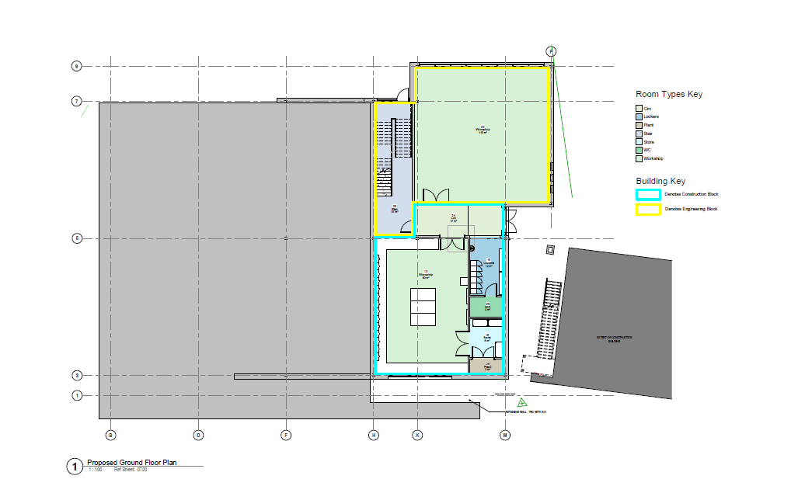

Engineering & Technology Centre First Floor

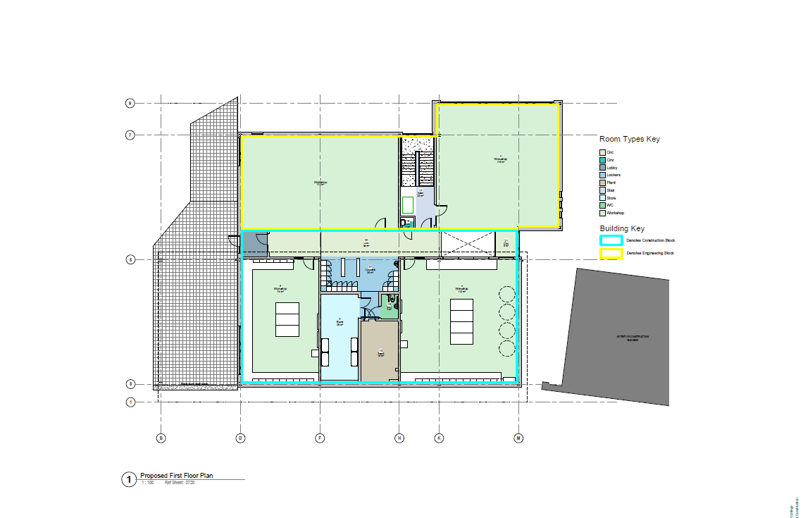

Construction Block Ground Floor

Construction Block First Floor

Creative Arts Centre Ground Floor

Creative Arts Centre First Floor

Wildman Street Ground Floor

Wildman Street First Floor

Westmorland Campus

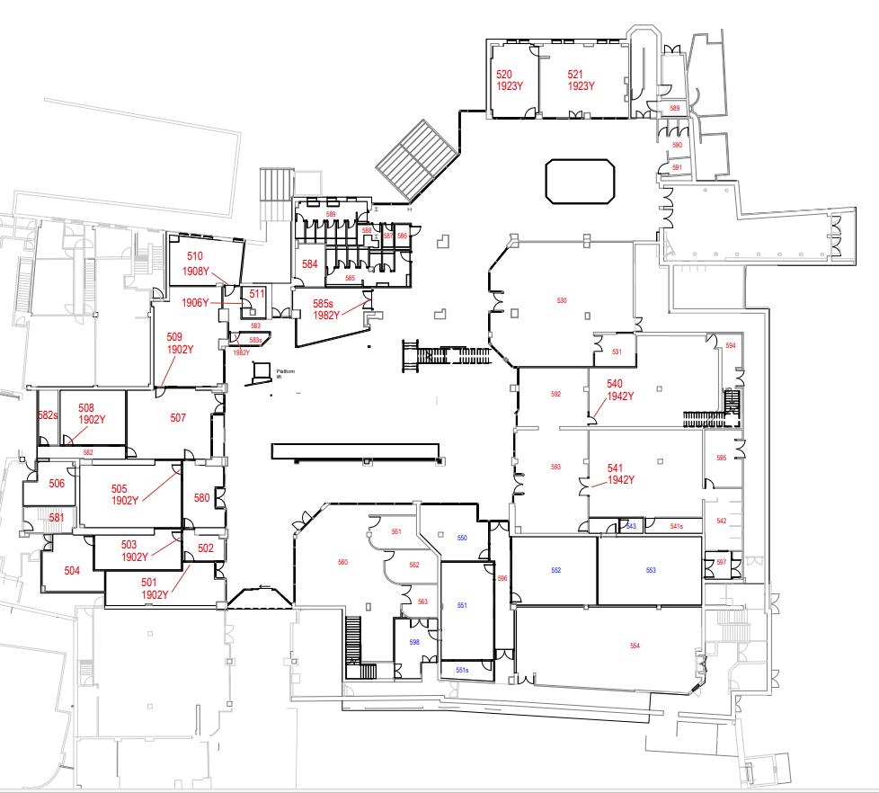

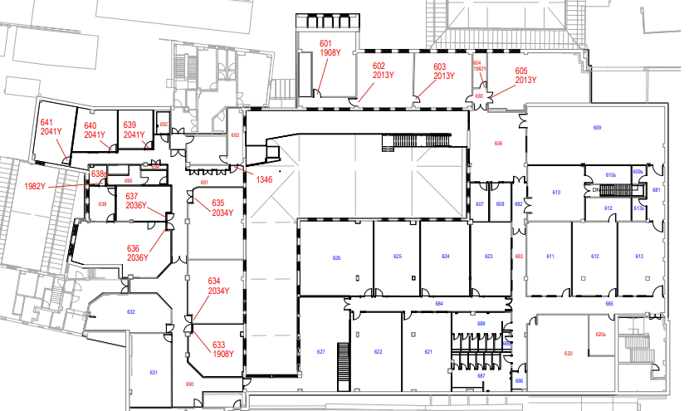

Media and Local Services Telephone Numbers
Appendix 3

Local Newspapers | Westmorland Gazette | 📞 01539 790252  Editor- Joy Yates  📞 07764 657056  joy.yates@newsquest.co.uk  News desk 📞 01539 790252  news@thewestmorlandgazette.co.uk
Local Newspapers | Lancashire Evening Post | 📞 07775 223458  lep.newsdesk@lep.co.uk
Local Radio | Radio Cumbria | 📞 01228 592444
Local Radio | Lakeland Radio | 07773 035 842  :  studio@lakedistrictradio.org
Local Radio | Beyond Radio | 📞 Call News: 01524 888 450 (option 3)
Police | Local Police non-emergency line | 📞 101
Hospital | NHS Non-Emergency line | 📞 111  01539 732288 Main reception WGH
Health & Safety Executive |  | 📞 0300 003 1647  Contact the Health and Safety Executive (hse.gov.uk)  Tell us about a health and safety issue - Contact HSE

Disaster/Incident Event Log
Appendix 4

To be completed by the Disaster Recovery Manager

Date: ______________________________ Start time: ____________________ End time: ____________________

Nature of disaster/incident: __________________________________________________________________________________________________

__________________________________________________________________________________________________________________________

Post disaster/incident learning points: ___________________________________________________________________________________________

__________________________________________________________________________________________________________________________

Event Log:

Time | Action | Delegated to | Date/Time Action Completed | Remarks



Total network documentation for Kendal College

Date | Author | Revisions
03/11/2022 | Mark Woof | Sequential list of disaster recovery tasks added.  Formatting changes
02/11/2022 | Mark Woof | Removed reference to Panda 360  Added information on WMC and storage of offline media.
Change Revisions
Contents
Introduction 3
Plan Overview 3
Objectives/Constraints 3
Incidents Requiring Action 3
Possible Contingencies: Areas of Risk 4
Physical Safeguards 5
Types of Computer Service Disruptions 6
Temperature Control (air conditioning) 6
Electrical 6
Fire 6
Ransomware 6
Phishing Attack 7
Security Strategies 7
Preparations for a disaster 7
General Procedures 8
Recovery Procedures 8
Overview of what is stored Offsite 10
Degraded operations 10
Recovery Time Objectives (RTO) 10
Data Backups and Restoration 12
Central Datacenter and Server Recovery Information: 13
Network and Telecommunication Recovery Information: 13
Application Recovery Information: 13
Restoration Location 13
Sequential list of disaster recovery tasks 16
Decision Making for a Data Center Disaster 17
Network disaster assessment phase 18
Disaster recovery activation phase 19
Alternate site operation / data center rebuild phase 21
Return home phase 22
Server recovery general information 23
Server recovery general task chart 23
Server inventory 25
Network inventory 25

Introduction

The Network Office is located on the 1st Floor of the Milnthorpe Road Campus, the servers that control the network are located in 3 different campuses (to mitigate total failure). These are all secure and air-conditioned rooms. A backup server is located within the AMC communication cabinet. Despite increasing size and complexity, the reliability of our network has been consistently high for many years.

Almost any disaster will require special funding from the College in order to allow the affected systems to be repaired or replaced. The plan assumes that these funds will be made available, from an insurance company or college funds, as required. Proper approval will be obtained before any funds are committed for recovery

Plan Overview

Plan Documentation Storage

Copies of this Plan, CD, and hard copies will be stored in secure. Copies will be given to key members of the DR Team to store at home. A master protected copy will be stored in both safes at each campus.

Objectives/Constraints

A major objective of this document is to define procedures for a contingency plan for recovery from the disruption of computer and/or network services. This disruption may come from the total destruction of a server room or from minor disruptive incidents. There is a great deal of similarity in the procedures to deal with the different types of incidents however special attention and emphasis is given to an orderly recovery and resumption of those operations that concern the critical business of running the College including providing support to curriculum activities relying on computer systems. Consideration is given to recovery within a reasonable time and within cost constraints.

All productions equipment that are vital for the daily operation of the college are covered by various maintenance contracts.

Incidents Requiring Action

The IT disaster recovery plan will be invoked when there is an actual or threatened circumstances that will result in “significant impairment” of the curriculum and/or administrative systems that the Network & Digital Learning Services team manages. This could include:

- An incident which has disabled or will disable, partially or completely, the curriculum network facilities for a period exceeding one business day.

- The loss of data that significantly exceeds the normal day to day restoration of student/staff files.

- An incident that has significantly impaired the use of computers and networks managed by Network & Digital Learning Services due to circumstances which fall beyond the normal processing of day-to-day operations.

- The threat of significant loss of data, systems or facilities.

- An incident which was caused by problems with computers and/or networks managed by Network & Digital Learning Services and has resulted in the injury of one or more persons.

Possible Contingencies: Areas of Risk

General situations that can destroy or interrupt the computer network usually occur under the following major categories:

- Power/Air Conditioning Interruption
- Fire
- Water ingress
- Weather and Natural Phenomenon
- Malicious damage (sabotage, hacking)
- Denial of service or virus attack
- Loss of network connectivity

Potential Disaster | Probability Rating | Impact Rating | Brief Description Of Potential Consequences & Remedial Actions
Power/Air Conditioning Interruption | 3 | 4 | UPS in place on the main productions server and DR server.
Fire | 3 | 4 | Fire and smoke detectors on all floors. Backups stored offsite
Water ingress | 5 | 4 | UPS in place on the main productions server and DR server.
Weather and Natural Phenomenon | 3 | 4 | All critical equipment is located on 1st Floor
Malicious Damage | 3 | 4 | Loss of data. Security systems in place, daily backups taken
Denial of Service or Virus attack | 3 | 4 | Loss of data. Security systems in place, daily backups taken. JA.NET migrate risks of DDOS in additional to onsite Firewall.
Loss of network connectivity | 2 | 4 | Upstream JANET network has built in redundancy and support. Switch to secondary connection at AMC.

Probability: 1=Very High, 5=Very Low Impact: 1=Total destruction, 5=Minor annoyance

There are different levels of severity of these contingencies necessitating different strategies and different types and levels of recovery. This plan covers strategies for:

- Partial recovery - operating at an alternate site.
- Full recovery - operating at the current main college site possibly with a degraded level of service for a period of time.

Physical Safeguards

All server rooms are protected by locked doors. All Network & Digital Learning Services have access to keys along with Estates. Network switch cabinets are in locked rooms or locked cabinets with restricted access.

Types of Computer Service Disruptions

This document includes hardware and software information, emergency information, and personnel information that will assist recovery from most types and levels of disruptive incidents that may involve networking facilities.

Some minor hardware problems do not disrupt service; maintenance is scheduled when convenient for these problems. Most hardware problems disrupting the total operation of the computers are fixed within a few hours.

Temperature Control (air conditioning)

Air conditioning units are the responsibility of Estates. Network & Digital Learning Services monitors the air conditioning in server rooms. Any faults are reported to the Estates team who would call in a suitable contractor, if necessary.

Electrical

In the event of an electrical outage, all servers and other critical equipment are protected from damage by Uninterruptible Power Supplies (UPSs). These units will maintain electrical service to our servers long enough for them to be shut down “gracefully”. Once electrical power is restored the servers will remain “powered down” until the UPSs are recharged by a sufficient amount to ensure the servers could be gracefully shut down in the event of a second power failure.

Fire

All server rooms are close to manual CO2 fire extinguishers, which will adequately protect the equipment from fires starting in the room itself. If a fire starts, the equipment could be used to limit damage to the affected piece of equipment and possible minor damage to equipment in the immediate vicinity. This would be handled as described in the preceding section: In the event of a catastrophic fire involving the entire building, we would most likely have to replace all our hardware. Our critical servers are backed up daily, to the AMC campus and copied by to a different location, other than the main communication room at MRC.

Ransomware
Please see the separate guide for this disruption – Playbook Ransomware

Phishing Attack
Microsoft filtering and our 3rd party AV provider should protect us from most phishing attempts. Please see the separate guide for this disruption – Playbook Phishing

Security Strategies

The college employs standard security strategies. For example, as far as possible, using standard software, hardware & local and wide area networking components. This includes Microsoft software on all PCs and laptops, Microsoft Office 365 and Windows Server software, switches and also routers. This industry standard approach will in itself permit reasonable mitigation of outage through market reliability and knowledge.

JISC firewall technology is employed (a) to prevent “rogue” access to the college network and resources and (b) to ensure the college network is employed for educational purposes, however the college recognises that our networks are increasingly “open” systems and like all networks are vulnerable to unauthorised access and that our information can be damaged by malicious individuals or carelessness.

Network security is a major consideration in our systems design. All our servers and workstations have automated systems to maintain them with up to date antivirus definitions and operating system updates. We recognise that we cannot achieve “absolute” security across all aspects of our activities for the most part, the security risks have been assessed and addressed corporately.

Individual users shall be made aware of their responsibilities with regard to how they can contribute to the overall security level. Guidance on good practice shall be provided to all users (curriculum and administrative, staff and students) and correspondingly special efforts shall be directed to those who are handling particularly sensitive information such as student record information, personnel information and financial information.

A system is in place to ensure the prompt removal of access rights, and the removal of data, of staff and students on leaving.

Preparations for a disaster

This section contains the steps necessary to prepare for a possible disaster and as preparation for implementing the recovery procedures. An important part of these procedures is ensuring that the off-site storage facility contains adequate and timely computer backup tapes and documentation for applications systems, operating systems, support packages, and operating procedures.

General Procedures

Responsibilities have been given for ensuring each of the following actions have been taken and that any updating needed is continued. The Network & Digital Learning Manager is responsible for

- Maintaining, reviewing and updating the IT disaster recovery plan.
- Ensuring that all members of the Network & Digital Learning Services receive copies of the Plan and are given the opportunity to discuss its implications.
- Ensuring that procedures are in place to ensure the scheduled rotation of backup media including the movement of weekly backup tapes.
- Maintaining and periodically updating IT disaster recovery materials, specifically documentation and systems information (electronically and manually).
- Maintaining a current asset register of equipment.
- Ensuring that UPS systems are functioning properly and that they are being checked periodically.
- Ensuring that the College is aware of appropriate disaster recovery procedures and any potential problems and consequences that could affect their operations.
- Ensuring that the proper environment is maintained in server areas.

Recovery Procedures

This portion of the disaster/recovery plan will be set into motion when an incident has occurred that requires the use of the alternate site, or the damage is such that operations can be restored, but only in a degraded mode in a reasonable time.

The following general steps must be taken:

- Determine the extent of the damage and if additional equipment and supplies are needed.
- Obtain approval for expenditure of funds to bring in any needed equipment and supplies.
- Notify local vendor marketing and/or service representatives if there is a need for immediate delivery of components to bring the computer systems to an operational level even in a degraded mode.
- If it is judged advisable, check with third-party vendors to see if a faster delivery schedule can be obtained.
- Notify vendor hardware support personnel that a priority should be placed on assistance to add and/or replace any additional components.
- Notify vendor systems support personnel that help is needed immediately to begin procedures to restore systems software.
- Order any additional electrical cables needed from suppliers.
- Rush order any essential technical supplies that may be needed.

For Ransomware and Phishing attacks, separate playbooks should be followed.

In addition to the general steps listed at the beginning of this section, the following additional major tasks must be followed in the use of the alternate site:
- Determine extent of damage and make a determination as to the following:
Is MRC Network and communication rooms operational/recoverable?
    - YES: Remain in place and initiate recovery accordingly.
    - NO: Make plans to move to the alternative location.
- Secure facilities as necessary, to prevent personnel injury and further damage to IT systems.
    - Shutdown any active components.
    - Physically secure facilities (data center, communication rooms, etc.) as necessary to prevent unauthorized access.
- Retrieve most recent on-site or off-site back-up media.
- Verify the operational ability of all equipment on-site in the affected area (servers, network equipment, ancillary equipment, etc.). If equipment is not operational, initiate actions to repair or replace as needed.
- Test systems, and communication equipment as required to validate physical operation and performance.
a. Server testing
b. Network testing
c. Desktop/Client testing
6. Upon restoration of the data center and servers to operational state:
a. Restore systems using virtualized images
b. If necessary, load operating system and test/validate
c. If necessary, load application software and test/validate
d. If necessary, load data and verify the integrity
- Prepare backup materials and return these to the off-site storage area.
- Set up operations in the alternate site.
- Coordinate activities to ensure the most critical jobs are being supported as needed.
- As alternate site provision is utilised, ensure that periodic backup procedures are being followed and materials are being placed in offsite storage periodically.
- Work out plans to ensure all critical support will be phased in.
- Keep SMT and staff informed of the status, progress, and problems.
- Coordinate the longer range plans with SMT of continuing support and ultimately restoring the overall system
- To ensure that if a breach of security has occurred that any access points are secured and passwords changed.

The Primary alternative site is the AMC Server room and Room 320. If this is unavailable, the server room and Room 506 at WMC would be used.

Overview of what is stored Offsite

- A current copy of this disaster recovery plan
- Copies of install disks for all relevant software and critical software/operating system images. These should be stored electronically rather than relying on internet-downloadable versions.

Degraded operations

In this event, it is assumed that an incident has occurred but that degraded operations can be set up. In addition to the general steps that are followed in either case, special steps need to be taken.

- Evaluate the extent of the damage, and if only degraded service can be obtained, determine how long it will be before full service can be restored.
- Replace hardware as needed to restore service to at least a degraded service.
- Perform system installation as needed to restore service. If backup files are needed and are not available from the on-site backup files, they will be transferred from the off-site storage.
- Work with the various vendors, as needed, to ensure support in restoring full service.
- Keep the SMT informed of the status, progress and problems.

Recovery Time Objectives (RTO)

The Recovery Time Objectives reflect the estimated recovery times based on current configurations and operations.

Network Service | Recovery Goal
LAN (Local Area Network) | 1-14 days estimate
WAN (Wide Area Network) | 5-10 days estimate
Internet | 1-7 days estimate
Application Recovery Tier | Recovery Goals
Tier 1 Applications | 1-3 day after LAN restored
Tier 2 Applications | 2 – 5 days after LAN restored
Tier 3 Applications | 7 -10 days after LAN restored

All Tier 1 classification is considered as critical applications which means these vital assets are considered as high priority during recovery stages. Following recovery of tier 1 services, the remain tiers will be restored.

Tier 1 Applications
JISC Router
Sophos Firewall
Nutanix Cluster
HPE/Aruba Core and central Switches
Domain Controllers
External DNS Servers
Certificate Servers
Backup Servers
Internal DNS Servers
Tier 2 Applications
NPS Server
File storage Servers
Telephone PBX Servers
MIS Servers
Door Entry Server
Deployment Servers
Inter campus Connection
Tier 3 Applications
Print Servers
Web hosting Servers
Modes/Hertiage Servers
MyKC Sync Server
Patch Management Servers

These RTO’s should be considered best-case estimates. Kendal College does have services located offsite running production applications. On-premise applications would be restored to this location per tier assignment.

In the event of a disaster, hardware would have to be located, purchased, shipped, installed, and configured before any software or data could be installed or restored to original location. The availability of the relevant equipment and shipping times could vary greatly depending on the timing and scope of the
disaster. Performance of applications during this period would be affected.

The network services and application recovery times are additive in case of a disaster that affects servers and the LAN. However, a WAN disaster takes significantly longer to recover from due to the installation schedules of telecommunications providers. During this delay, server and LAN recovery could be completed so the WAN recovery time would be the only time applicable to the RTO.

Data Backups and Restoration

Backup/Recovery files are required to return systems to a state where they contain the information and data that was resident on the system shortly prior to the disaster. System backups are governed by the Backup Procedure.

Kendal College does not have systems in place to backup and restore information/data located on individual desktop systems throughout the campus. Only the servers located in the datacenter are backed up; as such, only data resident on these systems will be able to be recovered. In the event that a disaster occurs on the campus which destroys personal computers, the information located on these computers will be extremely difficult or impossible to recover. If recovery is possible, it will require outside vendor involvement at great expense to the user.

The College recommends and encourages the use of network drives (on servers) to store all important files or within college approved cloud storage (OneDrive). The recovery of data not backed up to a network drive and/or full system backups are not covered under this plan

Central Datacenter and Server Recovery Information:

In the event of any disaster which disrupts the operations in the datacentre, re-establishing the datacentre will be the highest priority and a prerequisite for any IT recovery. As such, the Network department is required to have detailed information and records on the configuration of the datacenter and all servers and ancillary equipment located in the datacenter.
The network staff is responsible for keeping the hardware inventory up to date.

Network and Telecommunication Recovery Information:

In the event of any disaster which disrupts the network and/or telecommunications, re-establishing the connectivity and telephony will be a high priority and a prerequisite for any IT recovery. Recovery of these services will be accomplished in parallel or immediately following recovery of the datacentre. As such, the Network department is required to have detailed information and records on the configuration of the networking equipment. Detailed information of switches and routers is documented in our monitoring system.

Application Recovery Information:
Information necessary for the recovery and proper configuration of all application software located on the central servers is critical to assure that applications are recovered in the identical configuration as they existed prior to the disaster.

Restoration Location

Where possible the quickest form of recovery will be used. This will be determined based on the type of recovery needed and the extent of the damage. Below is listed an estimated time for each method

Windows Server Snapshot – 5 minutes per folder restore
Nutanix Snapshot – 5-20 minutes per VM
ObjectFirst – 1-3 hours per VM
Qnap NAS 1 - 2-5 hours per VM
Wasabi Offsite backup – Several hours per VM
Office365 Druva Backups - Several hours for full 365 retore

Training the disaster recovery team

The Disaster Recovery Coordinator is responsible for the coordination of training relating to the disaster recovery plan. The purpose of this training is twofold:

• To train recovery team participants who are required to execute plan segments in the event of a disaster.
• To train Kendal College management and key employees in disaster prevention and awareness and the need for disaster recovery planning.

The training of Kendal College personnel in disaster recovery planning benefits and objectives is crucial. A Disaster Recovery Plan must have the continued support from Kendal College’s personnel to ensure future effective participation in plan testing and updating. All personnel must be aware of the basic recovery strategy and how the plan provides for rapid recovery of their information technology systems support structure.

How to establish critical services and functions:

Department | Critical activities
Financial | • Financial management  • Emergency Funds  • Invoices for Repair and damages
Information Technology services | • Establishing Help desks for students and managements  • Permissions and Authorization  • Contingency management  • Procurement of IT services  • Request fulfillment
HR | • Establishing Executive communication  • Emotional support  • Payrolls
Estates | • Procurement of Emergency site and establishing command center setup  • Local security  • Basic utilities (power, gas, water and sewage)  •
Transportation facilities | • Establishing emergency transportation facilities
Others | • Meetings  • First responders. Police, fire, hospital

Sequential list of disaster recovery tasks

This section presents a sequential list of tasks to be performed during the four phases of a disaster. The list suggests a recommended order. In an actual disaster, some tasks could very well be performed before this list suggests they be performed.

The tasks are numbered as follows. Tasks for phase one begin with an A, phase two tasks begin with a B, phase three with a C and phase four with a D. Task numbers are sequenced by 10. In the team column, the primary team is listed along with the sub-team function. In some instances, multiple teams are responsible for the performance of a task. All teams/sub-teams will be listed in these cases. When a task has been completed, put a check in the X column.

Sometimes, the sequence may change depending on the type of disaster or circumstances at the time. Some tasks are ongoing, that is they span the entire phase or disaster. An example of this is task B180, which states that the Management Team coordinates activities of all teams. Some tasks are contiguous with others in that they can all be performed simultaneously.

Decision Making for a Data Center Disaster

Network disaster assessment phase

TASK NUMBER | PRIOR TASK | DESCRIPTION | TEAMS | X
A010 |  | Disaster Recovery Coordinator receives notification | MGMT/NTWK MGMT
A020 |  | Ensure that those affected by the problem are receiving emergency care | MGMT/NTWK MGMT
A030 | A010 | Assemble the Management Team | MGMT/NTWK MGMT
A040 | A030 | Assess damage and determine length of outage | MGMT/NTWK MGMT/NTWK
A050 | A040 | Declare Disaster | MGMT
A060 | A040 | Make arrangements with Police/Security Firm to secure the damaged area. | MGMT

Disaster recovery activation phase
TASK NUMBER | PRIOR TASK | DESCRIPTION | TEAMS/ SUB-TEAMS | X
B010 | A050 | Assemble Disaster Recovery Teams | MGMT/NTWK MGMT
B020 | B020 | Notify all Kendal College Staff | MGMT/ADMN
B030 | B020 | Gather offsite storage materials from offsite. | NTWK
B080 | B020 | Notify Insurance | MGMT/FINANCE MANAGER
B090 | B020 | Reassess the situation | MGMT/ADMN
B100 | B030 | Prepare statements for the media | MGMT/MARKETING MANAGER
B110 | B100 | Determine where to operate an alternate data center | MGMT/NTWK MGMT
B120 | B110 | Arrange for vendors to deliver equipment to the alternate data center | ESTATES
B130 | B120 | Secure the alternate data center | ESTATES
B140 | B130 | Coordinate arrival of equipment to the alternate data center | ESTATES/TECH
B150 | B130 | If necessary, acquire temporary office space | MGMT
B160 | B150 | Gather and distribute supplies at the Command Center | MGMT
B170 | B150 | Begin assessment of salvageable equipment and supplies | ESTATES

TASK NUMBER | PRIOR TASK | DESCRIPTION | TEAMS/ SUB-TEAMS | X
B190 | B180 | Set up an information desk at the Command Center | TECH
B200 | B170 | Pack and bring off-site materials to the alternate data center | TECH
B210 | B200 | Reassess the situation | MGMT/MGMT
B230 | B210 | Determine what the recovery point will be | TECH/NTWK MGMT
B240 | B230 | Notify Key Users of where the recovery point will be. | TECH
B250 | B240 | Make arrangements to process expenses during the disaster | MGMT/FINANCE
B280 | B270 | Restore the College Servers | TECH
B290 | B280 | Boot the College servers | TECH
B300 | B290 | Determine what information remote users will need to dial in to the alternate data center | TECH
B310 | B300 | Establish Communications from alternate data center to alternate work area | TECH
B330 | B320 | Test operating system | TECH
B340 | B330 | Test communications network | TEC
B350 | B340 | Test remote dial in | TECH
B360 | B350 | Begin restoration of application and user data | TECH

B370 | B360 | Test applications | TECH
B380 | B370 | Provide reports to appropriate users | TECH
B460 | Ongoing | Provide counseling to employees that require or request it | MGMT

Alternate site operation / data center rebuild phase

TASK NUMBER | PRIOR TASK | DESCRIPTION | TEAMS/ SUB-TEAMS | X
C010 | ON-GOING | Maintain control over disaster recovery expenses | MGMT
C020 | B450 | Establish system and application backup procedures | TECH
C040 | C020 | Arrange for an offsite storage facility at the alternate data center | TECH
C050 | C040 | Order communications equipment and hardware | MGMT
C100 | C060 | Construct or repair data center | ESTATES
C110 | C100 | Install equipment as it arrives | TECH
C120 | Ongoing | Provide counseling to employees that require or request it | MGMT

Return home phase
TASK NUMBER | PRIOR TASK | DESCRIPTION | TEAMS/ SUB-TEAMS | X
D010 | C110 | Determine appropriate date to resume processing at permanent data center | MGMT
D020 | D010 | Complete processing and take final backups (make two copies) | TECH
D030 | D020 | Shut systems down | TECH
D040 | D030 | Move all equipment to permanent data center | ALL
D050 | D040 | Install equipment | ALL
D060 | D050 | Test Operating systems and applications | TECH
D070 | D060 | Switch communications from the alternate site to permanent data center | TECH
D080 | D060 | Arrange to have the rest of the tapes and documentation shipped | TECH
D090 | D060 | Notify Users | TECH
D100 | D080 | Resume normal processing | TECH
D110 | D100 | Prepare media statements | MGMT/MARKETING MANAGER
D120 | D100 | Complete final disaster expense reports | MGMT/FINANCE
D130 | Ongoing | Provide counseling to employees that require or request it | MGMT
D140 | D120 | Update Disaster Recovery Plan based on lessons learned | MGMT

Server recovery

Server recovery general information
These procedures outline the steps required to restore any of College College’s servers. Recovery for the servers assumes that:
- Good backup data exists and can be retrieved from offsite storage

- Replacement servers will be procured with equal or greater capacity

- Network connectivity will be re-established

A decision must be made as to where the recovery will take place (alternate site, primary location). This decision is not made ahead of time since the specifics of the incident requiring recovery is not known.

Server recovery general task chart
This section is designed to be used to recover any COLLEGE Server. Some steps are not applicable to all disaster situations.

TASK NUMBER | TASK DESCRIPTION | COMPLETED
S010 | Assess the damage
S020 | Prioritize servers to recover
S030 | Order replacements for damaged equipment from vendors
S040 | Order appropriate cables, wires and network devices
S050 | Configure hardware as it arrives
S060 | Retrieve the backup hard drive from offsite storage
S070 | Test Server hardware

S080 | Install appropriate operating system on the server. Refer to the server info sheets to install the correct releases
S090 | Install network cards
S100 | Install cables on the server
S110 | Restore backed up data to the available disk drives using Windows Backup
S120 | Connect the servers to the network
S130 | Start applications for user verification
S140 | Contact users and coordinate verification
S150 | Verify user access to network
S160 | Resume normal processing

Server recovery

Server inventory

Asset inventory for all servers is available via internally accessible documentation.

Network recovery

Network inventory

Asset inventory for network devices is available via internally accessible documentation.

